Quadratic Inequalities 2 WS Name _____________________________________

Graph each quadratic inequality.

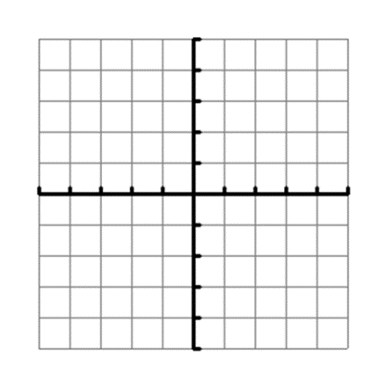1.  2. y ≥ 2(x – 2)(x – 2) 3. y < 2x2 − 8x + 8

4. What do graphs #1-3 have in common? ___________________________________________________________

Solve each quadratic inequality algebraically (using a number line). State the solution set in interval notation.

5. x2 + 2x − 3 ≥ 0 6. 9x2 – 2 ≤ −3x 7. 2x2 − 8x > − 6

8.  9.  10. 7x2 − 8x > 0